Hw3

B06705034資管二 吳禹辰

1.

(a) False

(b) False

(c) True

(d) True

(e) False

2.

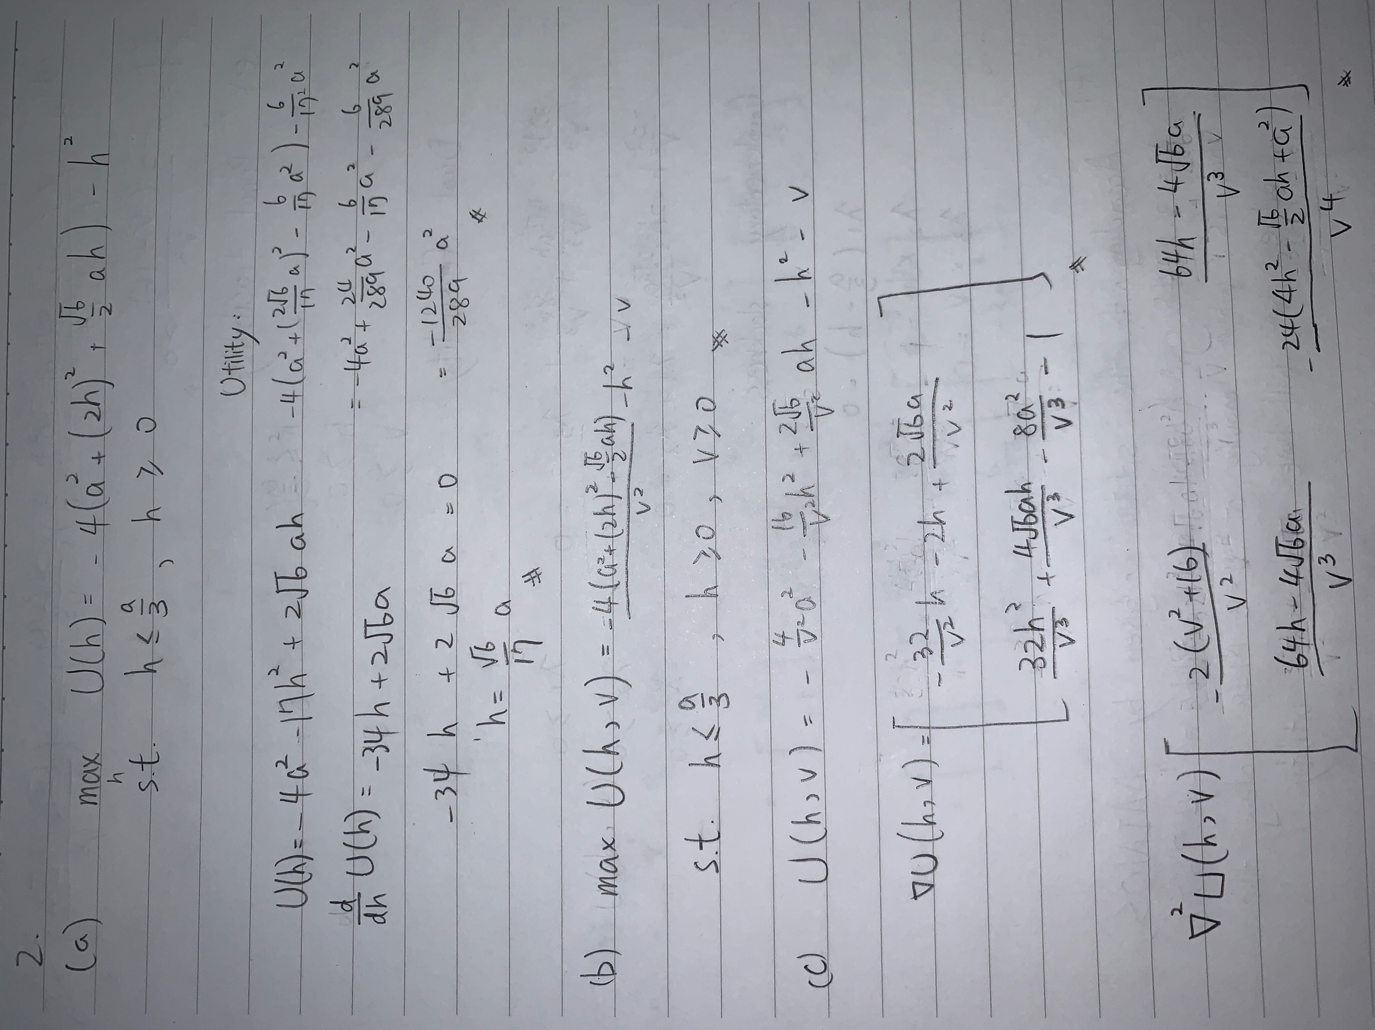

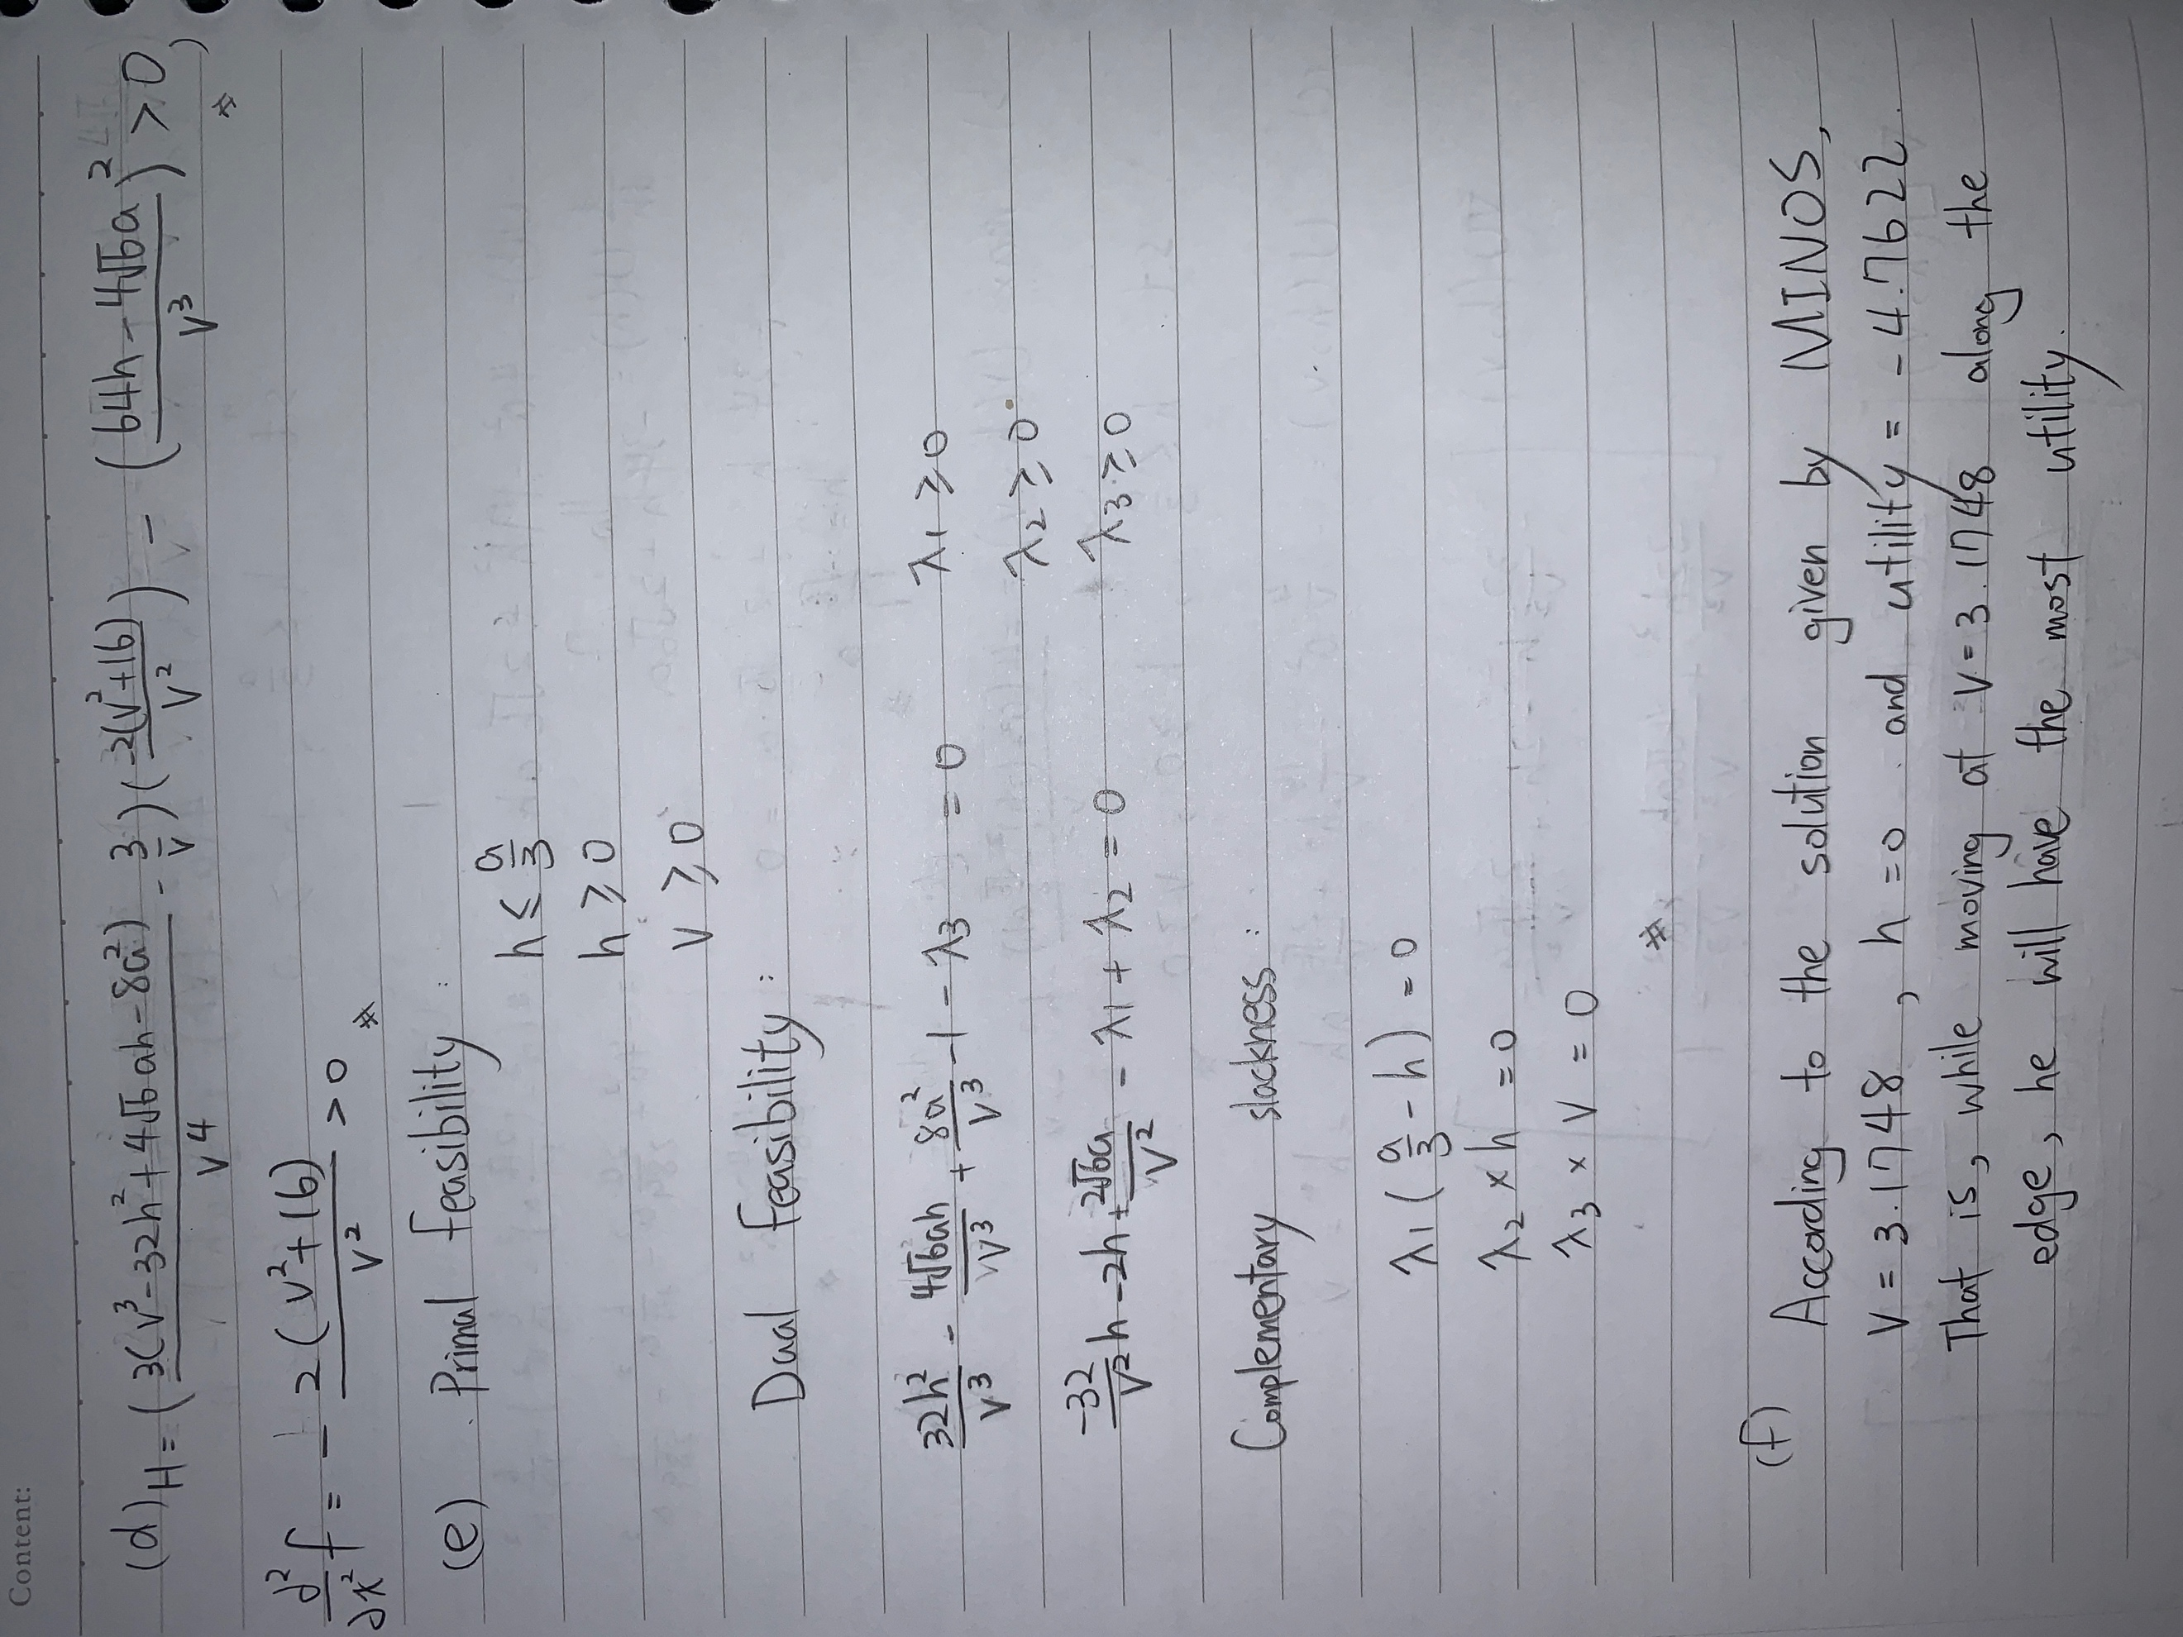

(f)

According to the solution given by MINOS, v = 3.08701, h=0.191894 and utility =

-4.667335231. That is, while moving at v= 3.08701 cross the pyramid at the route whose highest altitude is h = 0.191894, he will have the highest utility.

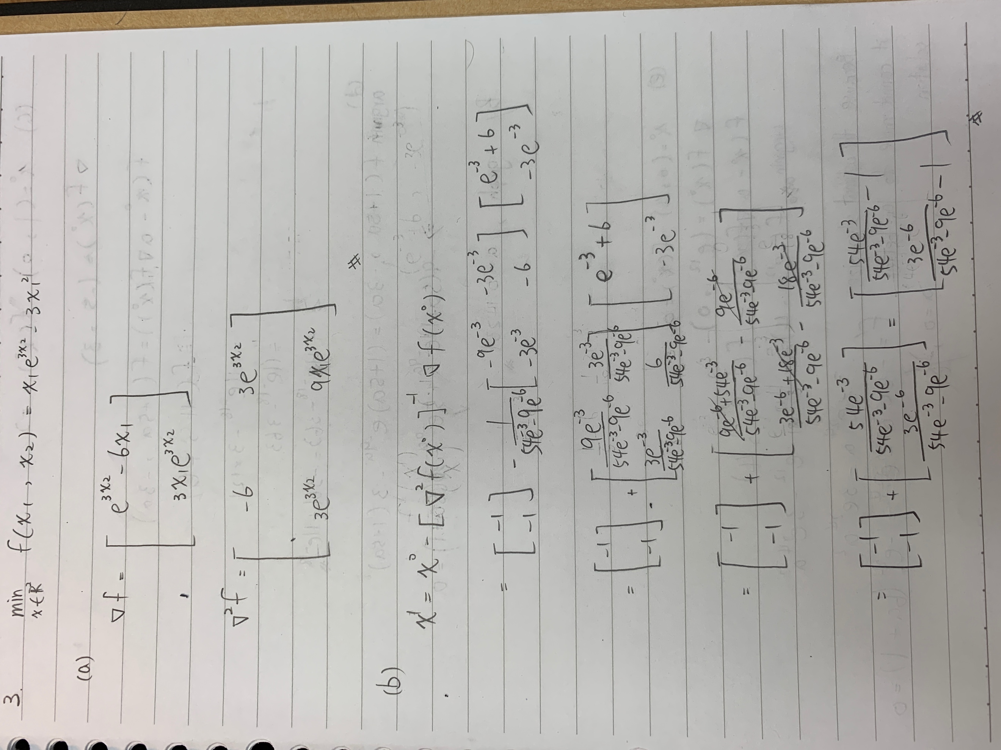

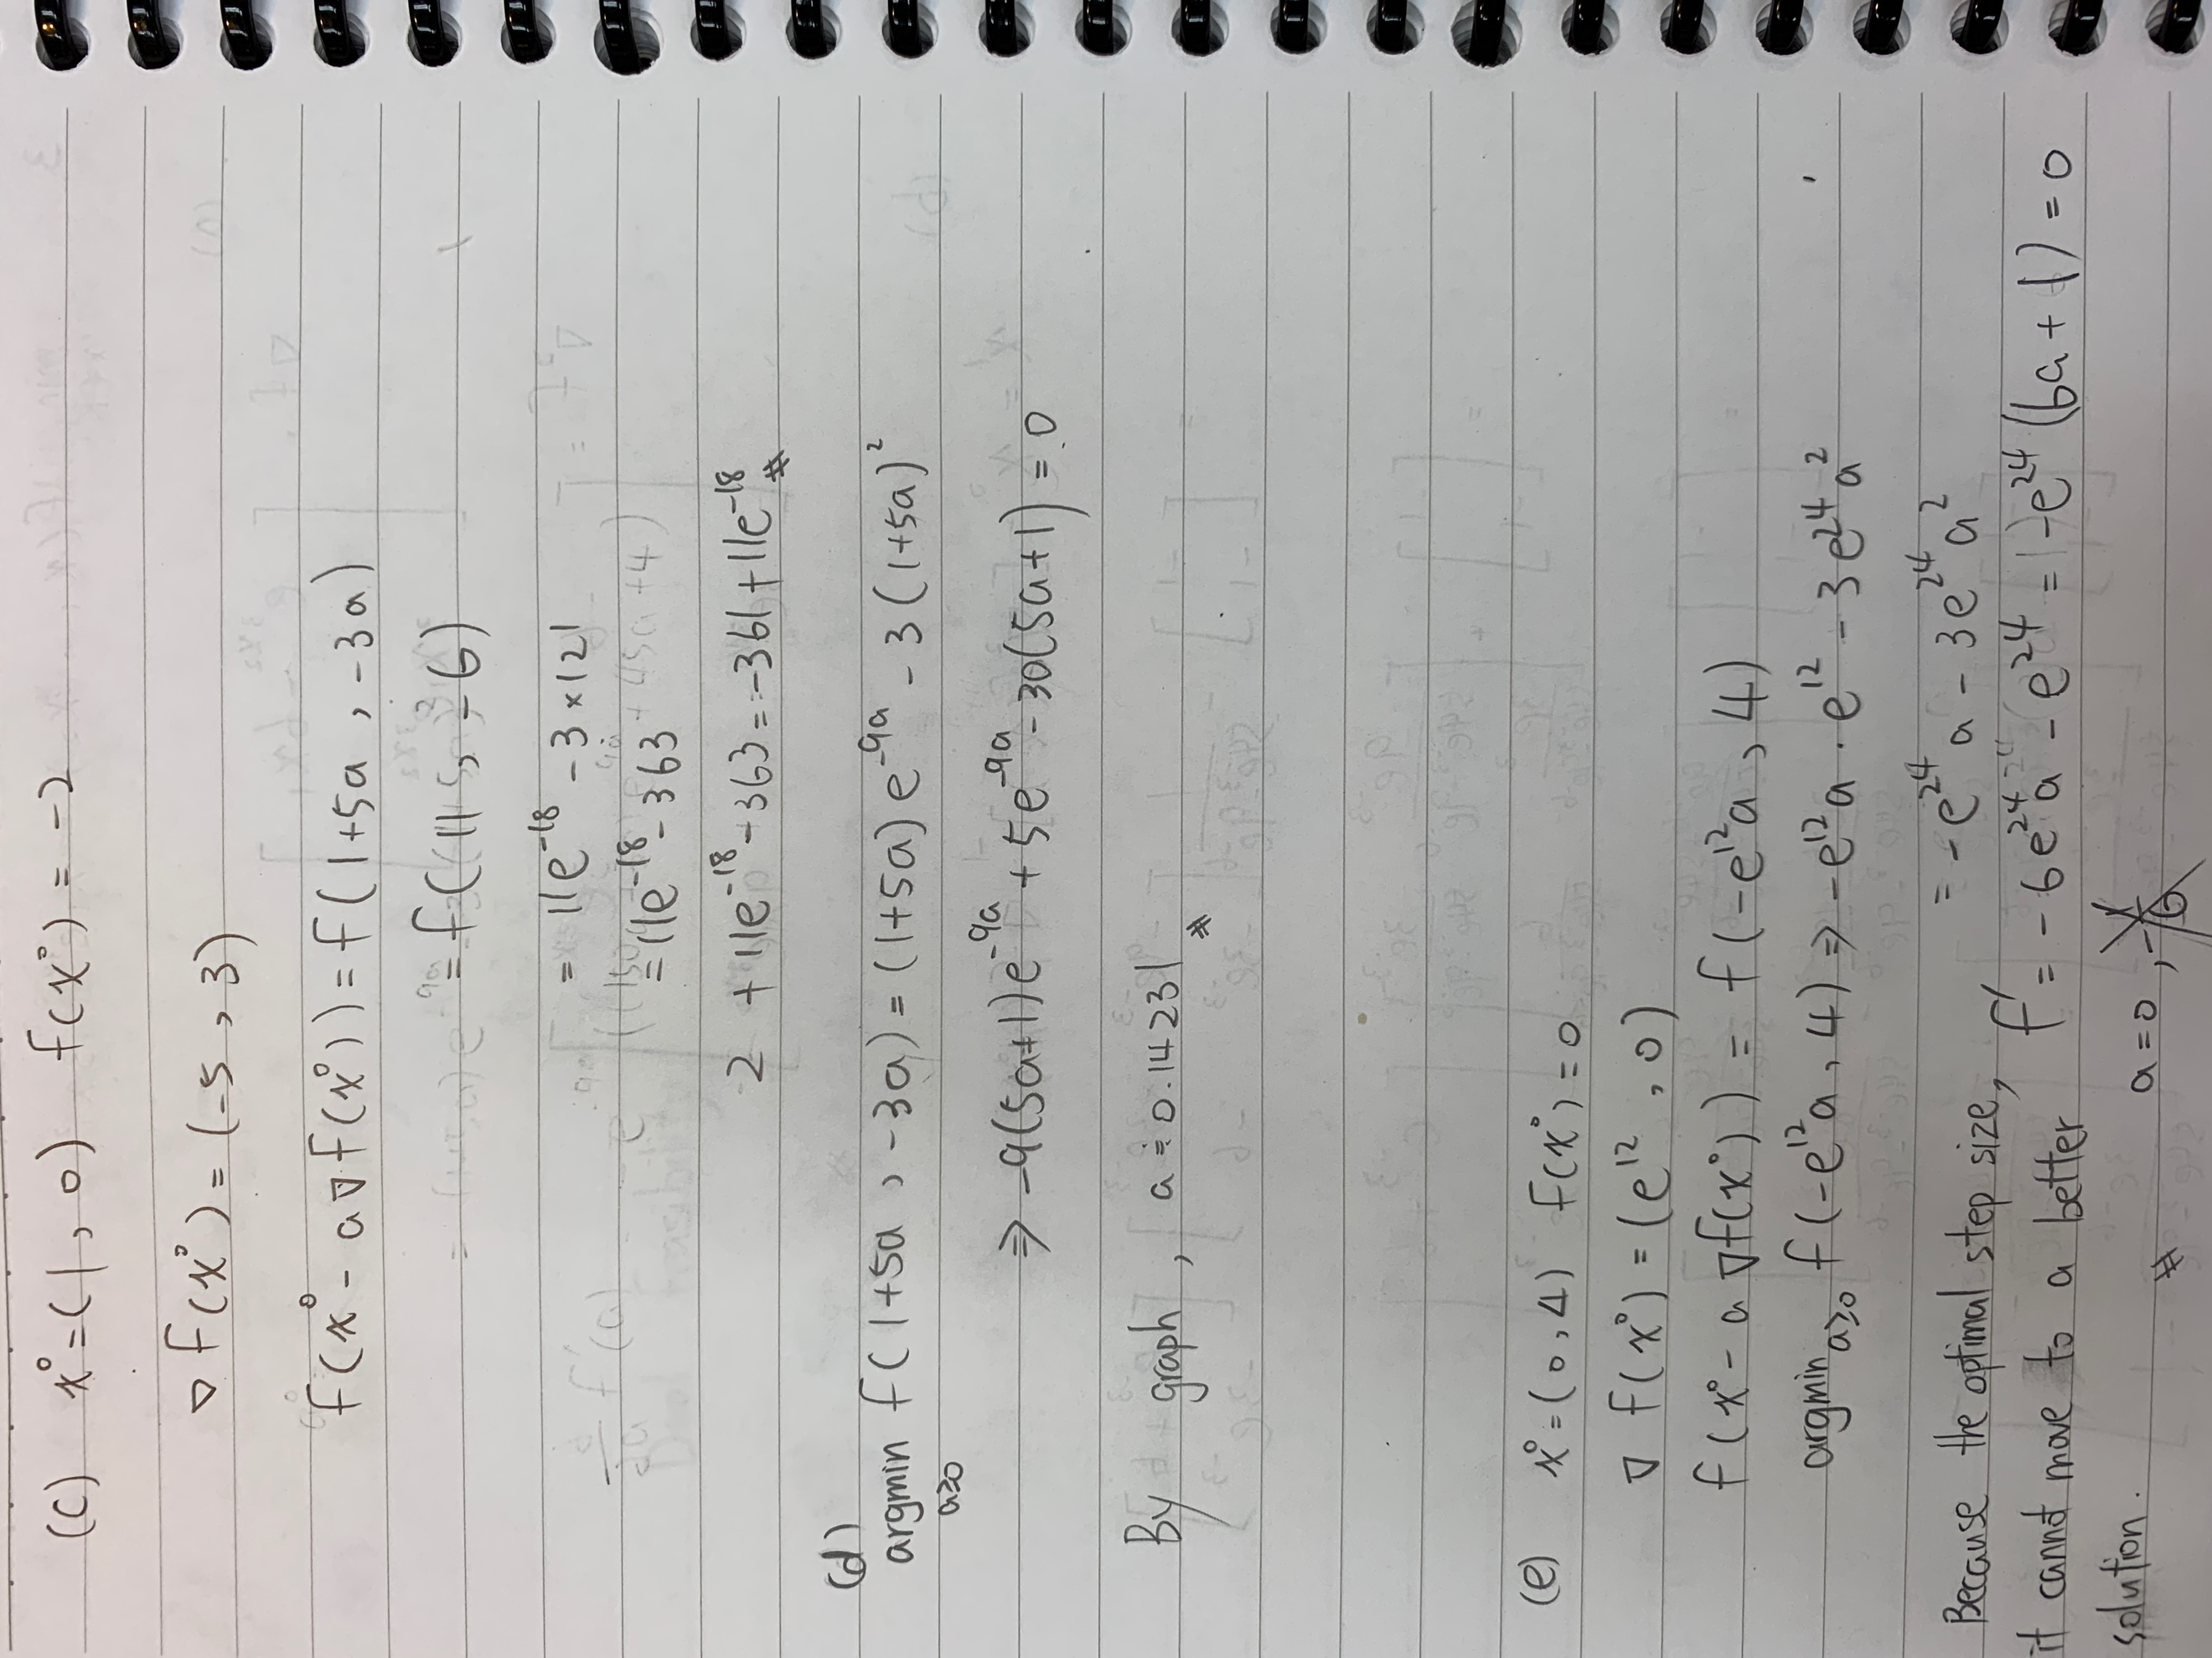

4.

(a)

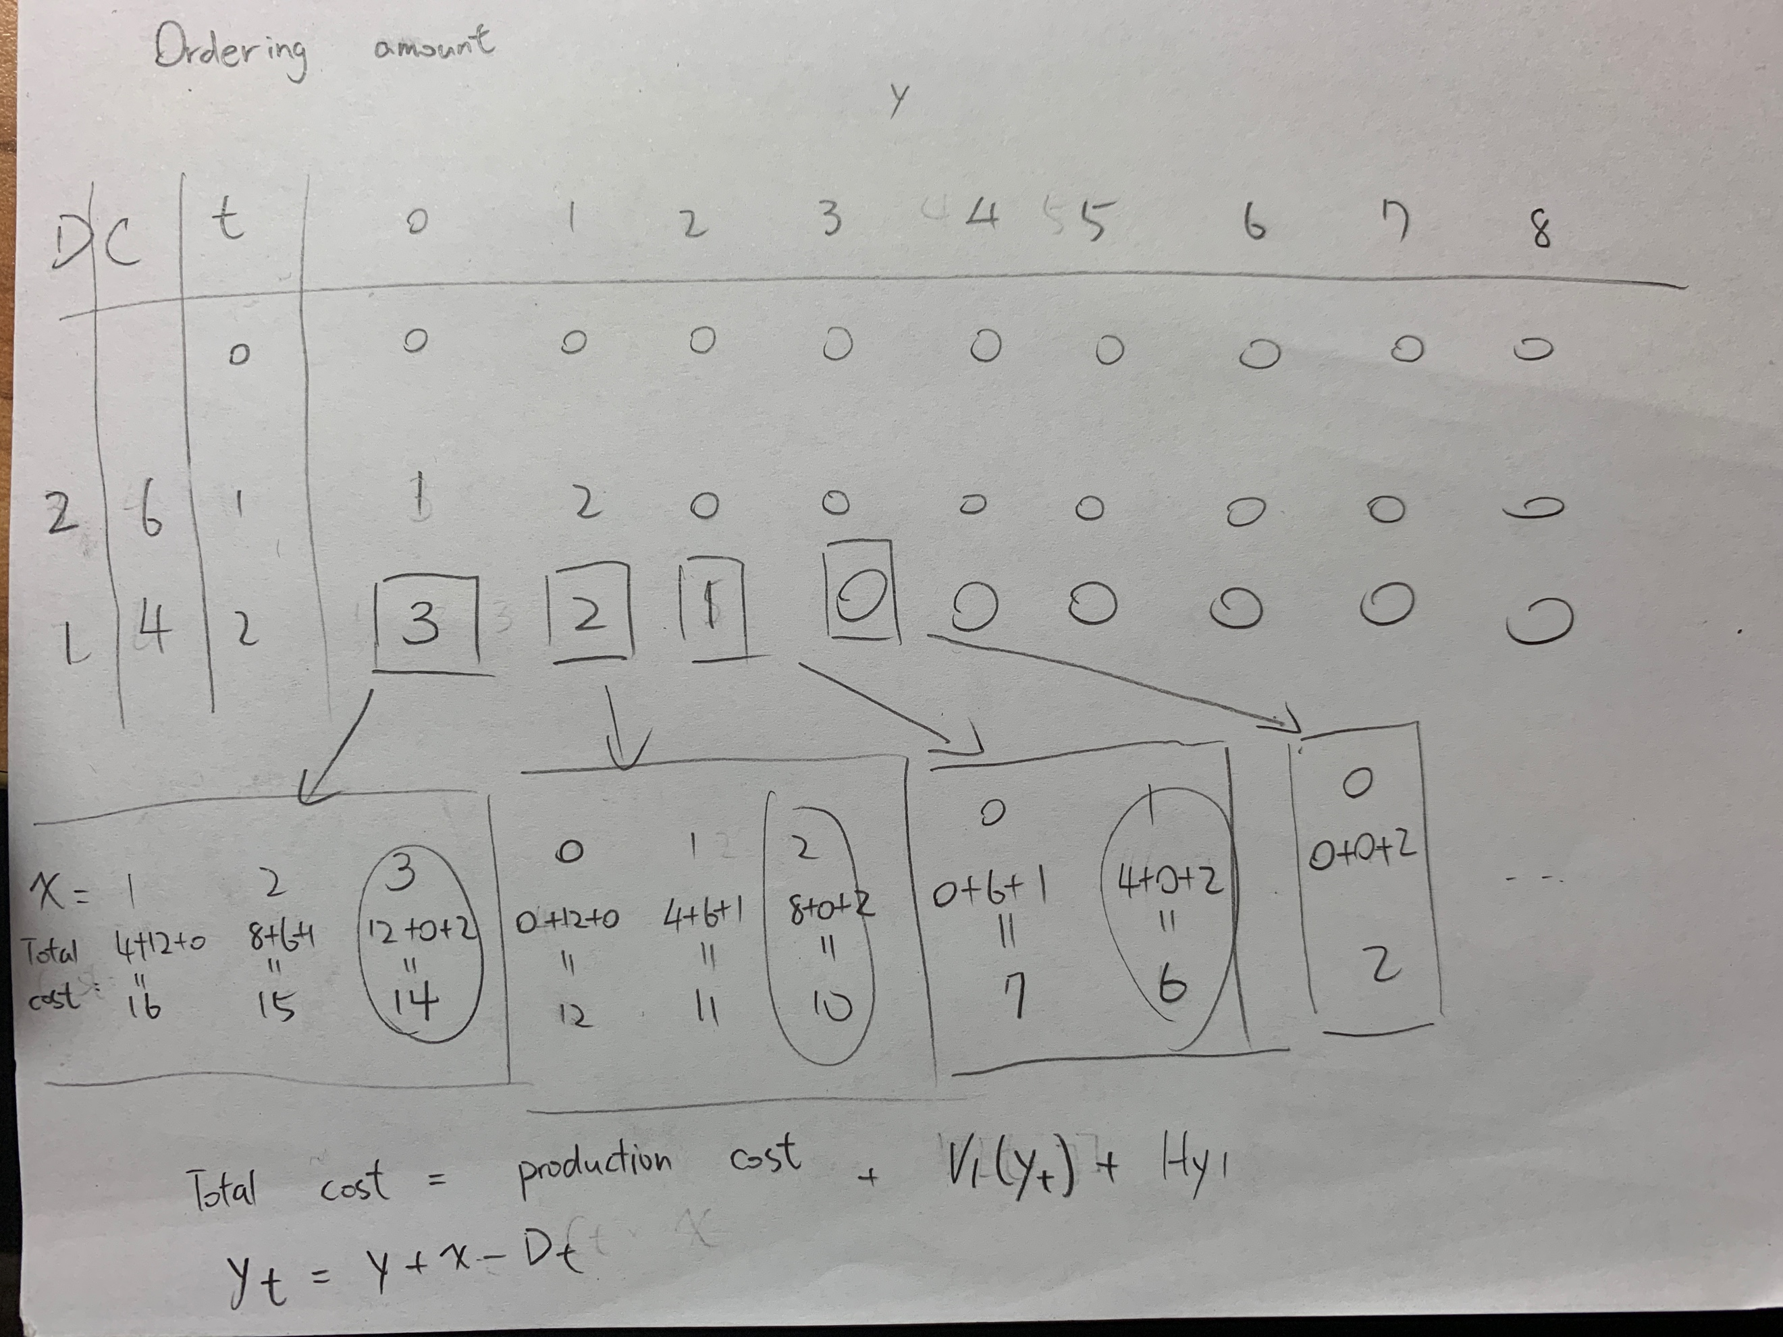

(b)

v=seq(0,10)

v4=vector(mode = "numeric",length = 10)

v3=vector(mode = "numeric",length = 10)

for (y in 1:10) {

for (q in 1:10) {

u=0

a=0

z=0

temp=0

for (x in 0:q) {

a=a+x\*dbinom(x,10,0.3)

}

for (x in q+1:10) {

z=z+q\*dbinom(x,10,0.3)

}

u = (a+z)\*5 -max((q-y),0)\*2

for (x in 0:q) {

temp=temp+v[q-x+1]\*dbinom(x,10,0.3)

}

v4[q]=u+temp

}

v3[y]=max(v4)

}

print(v3)

[1] 9.160202 11.160202 13.160202 15.160202 16.761276 17.950672

[7] 18.993040 19.999402 20.999976 22.000000

By using R, we find that the optimal number of $V_{1}(4)$ is 15.160202.